Junior Infants
Online Learning Resources

Songs
https://www.youtube.com/watch?v=pfRuLS-Vnjs

Maths
https://www.youtube.com/watch?v=Apb7dvLl5Yo&list=PLlyKrMV03_ohE-TfjcEdw3WhnONvc0r1x
https://www.youtube.com/channel/UCWKuiktSh-V3E4ysPU0VC3Q
https://www.topmarks.co.uk/ordering-and-sequencing/caterpillar-ordering

https://www.topmarks.co.uk/Search.aspx?Subject=37&AgeGroup=1
https://www.topmarks.co.uk/ordering-and-sequencing/shape-patterns

Literacy
https://www.youtube.com/watch?v=CWYuggn-Pvk
https://www.youtube.com/watch?v=TvMyssfAUx0
https://www.youtube.com/watch?v=J1ZludcLyi8
https://www.starfall.com/h/ltr-classic/

SESE
https://www.youtube.com/user/ComeOutsideTV

Active Breaks & Dances
Search Just Dance on YouTube
https://app.gonoodle.com/login

These are the letters we have been practising in class. Please ensure that when you are writing words or practising the letters that you begin at the starting point for each letter.
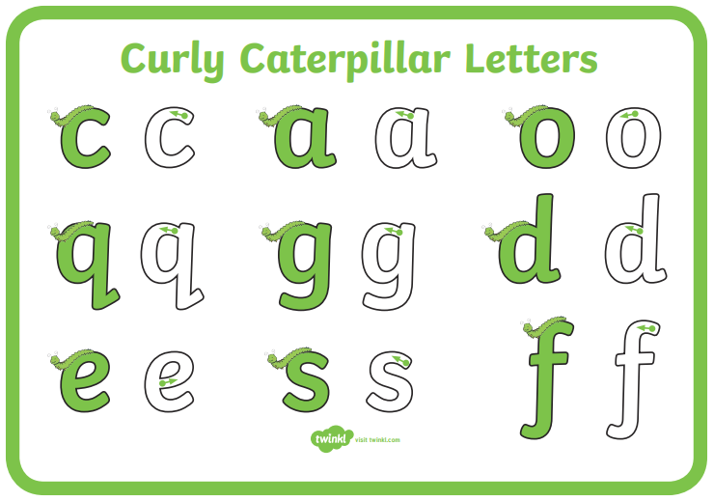

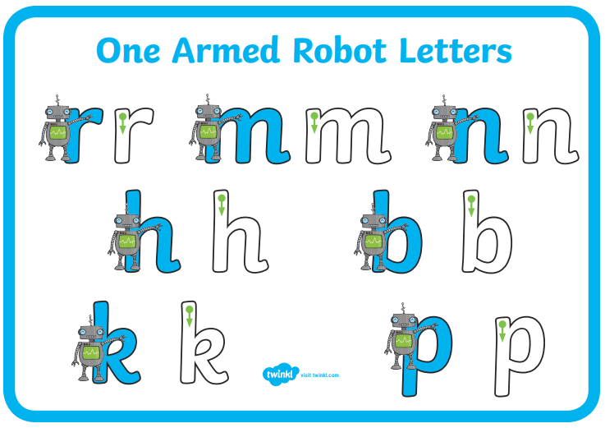

Help your child practise the correct number formation 1-5 and ensure they start from the correct starting position.
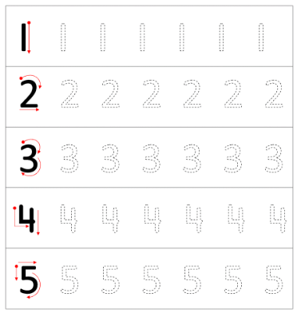

Jolly Phonics
Please go over all the sounds that we have learned
https://www.youtube.com/watch?v=U2HYM9VXz9k – Jolly Phonics Sounds
https://www.starfall.com/h/ltr-classic/

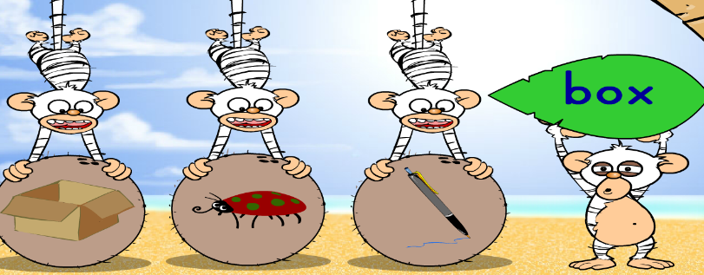
https://www.topmarks.co.uk/Search.aspx?q=cvc

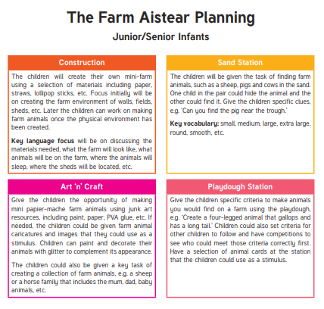

We have also started learning about The Farm and you encourage your child to do some of the activities above.
https://www.topmarks.co.uk/Search.aspx?q=farm – TopMarks Farm Games

