**Welcome New Junior Infants**

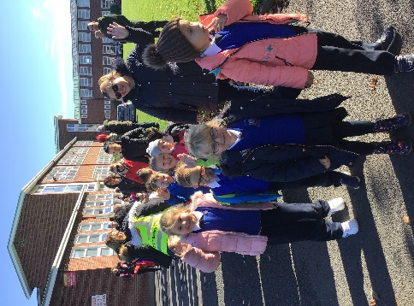This term we were very excited to welcome 5 new classes of Junior Infants to Assumption Junior School! The boys and girls have settled in well and made lots of new friends. Their rooms are full of beautiful artwork and colour already.

**Road Safety**

Autumn is here, and the mornings are getting darker, so we want all our pupils to be careful travelling to school. A big thank you to Jackie and Yvonne, the school's lollipop ladies, who came in to talk to the Senior Infant classes about Road Safety.

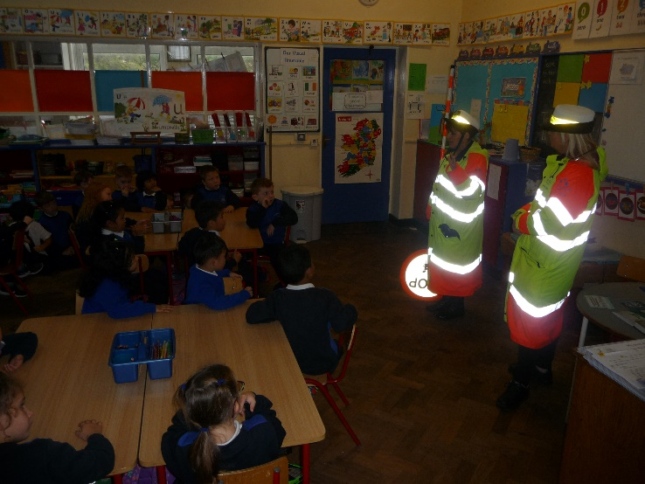

They reminded us of some important safety messages when coming to school:

* Always hold a grown-up’s hand when crossing the road.
* Always follow the instructions of the lollipop person where you are crossing.
* Be safe and be seen, especially as the mornings and evenings are now getting darker!

**Sponsored Walk**

Our annual Sponsored Walk took place on October 15th this year. All classes took part and really enjoyed their walk on a lovely Autumn day. A big thank you to all the parents and friends who walked with us on the day and thank you too for helping your child raise sponsorship money. The school relies on these generous donations to stay well-resourced throughout the year. All classes had fun on a bouncy castle obstacle course after their walk!

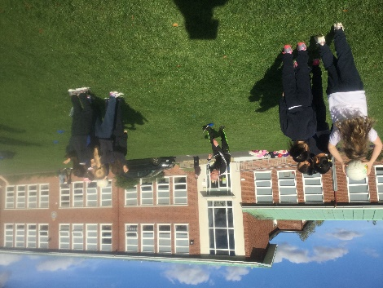

**Being Active at School**

**Sponsored Walk and GAA Skills**

**GAA Coaching**

Second class and some first classes are currently doing GAA in school. Paddy from Good Counsel GAA club comes in each Monday to teach the girls and boys a variety of skills. All class groups will avail of this during this school year. We are very lucky to have 2 clubs involved in our school. James Gaels GAA club will also be coaching us this year. Watch this space for future GAA stars!!

**Maths Week**

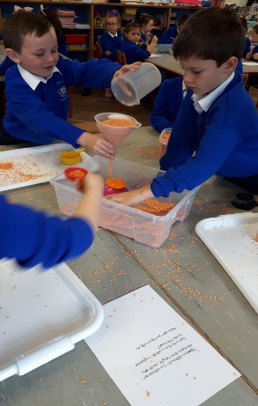All classes took part in Maths Week last week. Great fun was had as the boys and girls completed lots of activities across all the maths curriculum. Here you can see First Class working on measures. 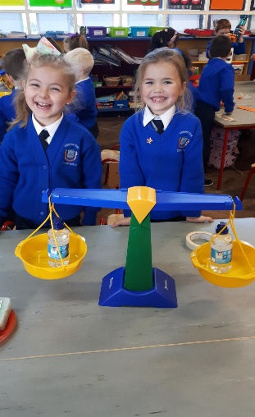

**School Closures**

October 25th (closed for staff planning day)

October 26th (closed for polling)

October 29th – November 4th (mid-term break)

**Check out our website for regular updates and news:**

www.assumptionjns.com