**Sponsored Walk**

Thank you for supporting our Annual Sponsored Walk. This year we raised a total of €12,500 between the two schools. It is the first time we ran the walk on a school day and this will be reviewed in the new year before a decision is made whether to revert back to a Sunday for next year. We’ll keep you posted! The money raised from the walk goes into a joint fund towards the upkeep of the school. This year, to celebrate our 60th Anniversary, the schools are planning to invest in our school hall. We will have more news on this in the new year.

**Access Issues**

The Board of Management takes its responsibility around pupil safety very seriously. We are acutely aware that the situation with parking and pedestrian access around the school is far from ideal. Last term the joint Boards of the schools employed a consultant engineer to make an application to the Department of Education for emergency funding to solve our access issues. Unfortunately, this application was turned down. We haven’t given up however, and the Boards are currently exploring other options. Watch this space for future developments.

**School Funds**

Thank you to all parents who have paid this year’s books and requisites bill or set up a payment plan to pay in instalments. The money you contribute is essential, not just for the workbooks your child uses but also to cover book rental texts, installation of interactive boards in all classes, purchase of Aistear materials, IT and PE equipment and all photocopying and art supplies. When all parents contribute, we can maintain a well-resourced school that benefits all pupils. Unfortunately grants received from the Department of Education barely cover the essentials of heating, lighting and cleaning the school and your contribution for what your child uses is essential. If you would like to set up a payment plan, please contact Nora in the school office.

**Christmas Coffee Morning**

Our wonderful Parents’ Council have been as busy as Santa’s elves preparing for our annual Christmas Coffee Morning on Friday, December 7th! The Scholastic Book fair will be running on the same day and we hope you can support our Christmas Coffee Morning as it’s always a festive, seasonal event.

**Science Week 2018**

We celebrated Science Week during November. First Class held a science fair for their parents and Second Class paid a visit to the local girls’ secondary school where they visited the science labs.



**Sacraments**

Many of the girls in Second Class took part in their Communion Enrolment Ceremony on November 14th. It was a very special night for the girls and their families and we are very proud of the work they put in preparing for the ceremony. Some other dates of note for the girls are:

December 5th – Advent mass at 10am in Church

March 28th – First Confession at 7pm in Church

May 18th – First Holy Communion at 12pm in Church

**Community Links**

Here at Assumption Junior we always love to host visitors who help us from the local community. This month the boys from rooms 17 and 18A welcomed our Community Garda to the school. They heard all about the important work the Gardaí do to help us.

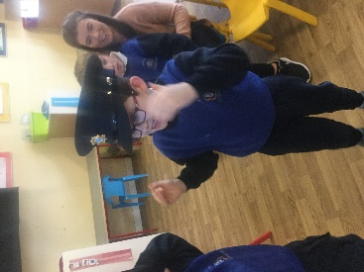

**Ellie’s Xmas Heart**

This Christmas we are supporting Ellie’s Xmas Heart, a toy appeal for Crumlin Children’s Hospital. If you would like to donate any new, unwrapped toys please leave them in the office with Nora. Thanks for your support.