Welcome New Junior Infants
This term we were very excited to welcome 5 new classes of Junior Infants to Assumption Junior School! The boys and girls have settled in well and made lots of new friends. Their rooms are full of beautiful artwork and colour already and they are busily enjoying their Aistear theme “The Birthday Party”. They have been doing lots of sorting at maths time and learning about colours and shapes.
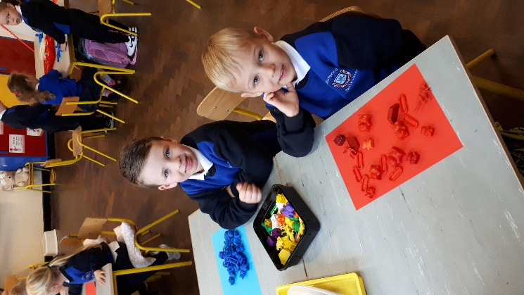
Pupil Safety
Thank you for your great cooperation with our new door system. We have seen huge benefits to our pupils’ safety and security since the start of the year due to the new fobbing system. We would also like to remind you that it is not permitted to climb or lift children across the fence at the Long Mile Road. This extremely dangerous practice has in the past led to children being injured and it is important for parents to take responsibility in this matter. Parents are not permitted to drive into the school grounds without special permission. We have very young pupils walking in the school grounds in the morning and at home times and we would ask for your help in keeping the school as safe as possible for all of the children.
Books and Resources
Thank you to all parents who have paid their child’s book bills or set up a payment plan this year. This year we entered all pupils whose book bill was paid in full before the end of June into a raffle to win a refund on their payment. Congratulations to the following pupils who have won the raffle:
- Junior Infants - Seán Purdy
- Senior Infants - Aileen Dulqamoni
- First Class - Harrison Donohoe & Cameron Kirwan
- Second Class - Lilly Reilly
Medications
If your child requires medication in school, please ensure that you have completed a medications form as teachers cannot administer medicines without this. Forms are available in Nora’s office. Please also remember to keep a check on the dates on your child’s medication and send in replacements before they go out of date.
Our Curriculum
Every month in our Newsletter we will focus on one aspect of the curriculum. This month on the back of the newsletter we have included some tips on maths for the infant classes taken from the NCCA (https://www.ncca.ie/en/primary/resources-for-parents) Ms McCann is our maths co-ordinator in the school and this year she will be working with the teachers to develop new ways to introduce maths to the children across the school day. Talk to your child about number, shape and pattern in the local environment, play simple card and number games like snakes and ladders and help them see how real maths is in their lives. Maths is everywhere!
First Communion
First Holy Communion will take place on Saturday, May 16th at 11.30am in the parish Church. We have had a donation of two new, unworn Communion dresses, age 7/8 and 10/11 approximately. If you are interested in speaking to Nora or Ms Leonard discretely about the dresses just pop into the office and your enquiry will be kept strictly confidential.
School Self-Evaluation
This year we are focussing on the writing process as our area for evaluation and improvement. You can help us by encouraging your child to take any opportunities they get to write for fun outside of school.
Check out our website for regular updates and news:
www.assumptionjns.com

