Road Safety Awareness
We were delighted to welcome Road Safety Authority Education Officer Orlaith Maguire to the school this month to give information workshops to many of our Infant classes. We went on a walk around the local area with the help of the RSA and our local Gardaí. We focussed on crossing the road safely, following traffic signals and being visible. Orlaith will visit the rest of the classes during November to take about the Safe Cross Code and we hope that our road safety walk will become an annual event.
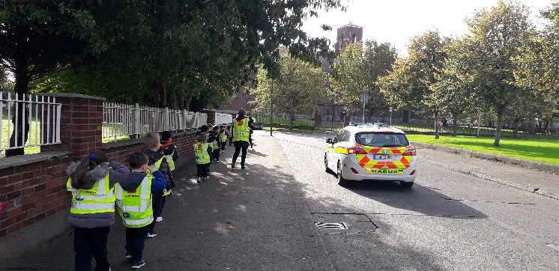
Every School Day Counts!
This November schools across the country are taking part in the Every School Day Counts initiative to encourage full attendance for the 20 school days of November. We have included some tips on the back of this newsletter to help you make sure your child gets to school every day. At the end of the month there will be a party for the class with the best attendance and parents of all pupils who miss no days in November will be entered into a raffle. Getting to school on time is also a very important part of attendance and being late in the mornings means that children are missing out on schoolwork and on vital socialisation with their classmates. It’s essential to allow children to build their independence by coming into school in the line with their classmates in the morning.
Dates to Note:
- Parent-Teacher Meetings: November 19th to 21st – you will be contacted by your child’s teacher regarding individual meeting times
- After-School Cancelled: November 18th to 22nd to facilitate Parent-Teacher Meetings
- Junior Infant Nativity Play: December 10th at 12.30pm in the school hall
www.assumptionjns.com
New Facilities
In September we opened our new Movement Room. This space allows pupils to work on their gross motor skills and also provides a calming sensory room. Feedback has been very positive and both staff and pupils are enjoying using the new facilities as you can see!
Maths Week
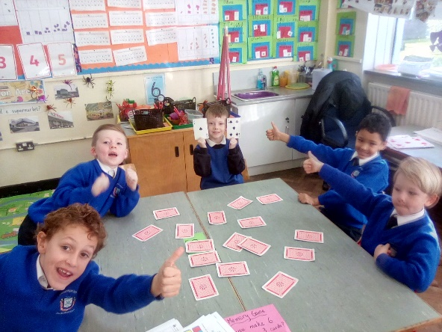
During October we celebrated Maths Week. All classes in the school took part in fun maths activities, games and maths trails. We all used our “maths eyes” to see how maths is all around us in our everyday lives.
First Communion
We have had a donation of two new, unworn Communion dresses, age 7/8 and 10/11 approximately. If you are interested in speaking to Nora or Ms Leonard discretely about the dresses just pop into the office and your enquiry will be kept strictly confidential.
Halloween
Unfortunately, we had to postpone our Fancy-Dress Sponsored Walk today due to bad weather but thankfully the weather didn’t stop the children and school staff from coming to school in amazing fancy dress costumes! We hardly recognised most of the children, such a huge effort had gone into their costumes and face paints. We hope you all have a lovely and safe Halloween mid-term break and school will reopen on Monday, November 4th at 8.50am
Office Times
The school office will be closed from 12.30 to 1pm daily to allow Nora to have her lunch. If you call to the school during this time you will have to wait until 1pm for assistance.

