Seachtain na Gaeilge
In March we celebrated Seachtain na Gaeilge. All the children made a big effort to use lots of Gaeilge in the classroom, the yard and at home. Maith sibh! On Thursday 14th March we had a Lá Glas. Everyone looked great in their green outfits. Well done to all the classes that took part in our special assembly. It was great to hear lots of songs and poems as Gaeilge. Some of our teachers even joined in and played us some lovely traditional Irish music!
Ms O’Reilly played her
Harp and Ms Henshaw
played the fiddle.

Even though Seachtain na Gaeilge is over, we want to keep using our Gaeilge as much as we can. Is aoibhinn linn Gaeilge! 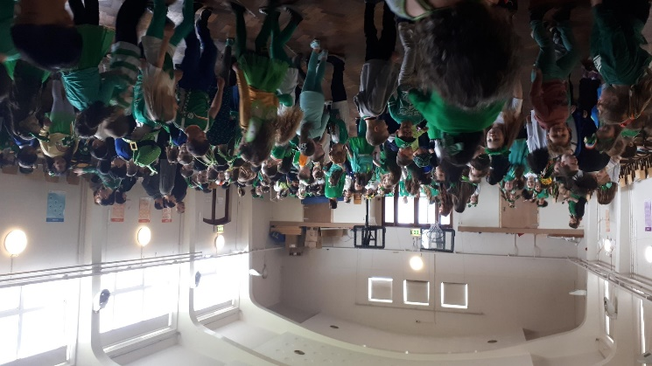
First and Second Class at their Céilí Mór
World Book Day
We had great fun on World Book Day this month. The children came to school dressed as characters from their favourite books. The older classes joined up with our infant classes for some lovely buddy reading sessions. Ms Branigan set up a library space in the Blue Hall and all classes visited and spent some time reading with their friends and teachers. To find out more information about World Book Day follow this link: https://www.worldbookday.com/world-book-day-ireland/
Book Fair
This month we also hosted the Scholastic Book Fair. This was a great opportunity for our parents and children to buy new books for shared reading time. The other wonderful thing about the book fair is that the school receives up to 60% of the value of the books sold back in books for our classes!

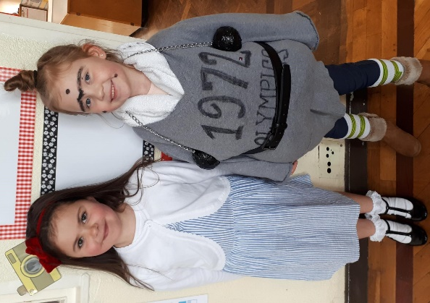
Two of our World Book
Day characters!

Pyjama Day
Second Class hosted a Pyjama Day to raise money for Childline this month. Well done to all the girls for taking part and contributing and a special mention for Ms Dingivan who abseiled from the top of Croke Park recently to raise additional funds for Childline!
First Class Play
First Class have been busily learning their lines and rehearsing their songs for their upcoming performances of Cinderella. We’re all very excited about the plays and can’t wait to see our fantastic actors on the day. The cost of entry to the show will be €5 and as we have to hire sound equipment for the day the money raised will go to fund this and also towards the sets.
Dates of Note
April 11th 11am and 1pm (Cinderella performed by First Class)
April 12th (closing at 12pm for Easter Holidays)
April 29th (Term 3 begins)
May 24th (Closed for Polling)
Check out our website for regular updates: www.assumptionjns.comor follow us on Twitter @assumptionJNS

