Mark Aikenhead Day
This month we celebrated the birthday of the foundress of the Religious Sisters of Charity, Mary Aikenhead. We held a special assembly and the pupils took part in colouring and writing competitions for the special occasion. Sr Lorraine told us all about Mary Aikenhead’s life and 8 of our pupils received special certificates from the Religious Sisters of Charity. If you would like to learn more about Mary Aikenhead and the work of the Religious Sisters of Charity check out this link: https://religioussistersofcharity.ie/
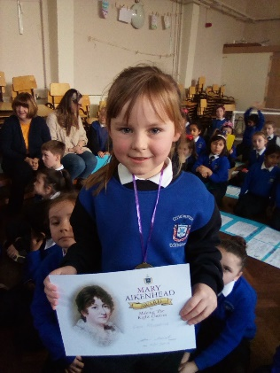
Catholic Schools Week
This month we have celebrated Catholic Schools Week. During the week we celebrated the diversity in our school by making beautiful new welcome signs in lots of different languages for display in our entrance hall. See if you can spot them on your next visit! We also were delighted to welcome lots of our pupils’ grandparents into the school during the week. We understand the special role grandparents play in the pupils’ lives and great fun was had in all classes by grandparents and pupils alike. A huge thank you to all the grandparents and other special adults who visited us on Thursday and took part in playground games, board games, crafts and reading. We hope you’ll come back to visit us again soon.
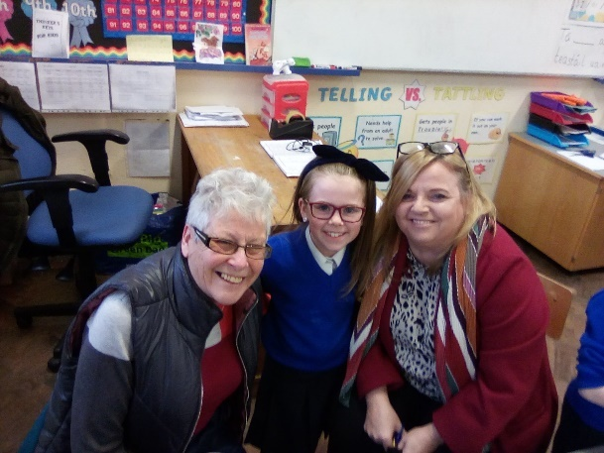
School Self-Evaluation
This year we are evaluating the ways we teach PE and encourage activity throughout the school. The teachers on the PE Committee have been hard at work on this area all year and had their first PE committee meeting with 1st and 2nd class children this month. The pupils made posters for our ‘Active Breaks’ to help us become more active in school. A number of teachers have been trained in the area of Fundamental Movement Skills (FMS), and this is being introduced into our PE lessons. To find out more about FMS follow this link: https://www.scoilnet.ie/pdst/physlit/fms/
Aistear News
Our infant classes have been using Aistear methodologies (learning through play experiences) to learn about our local community. This month our Community Gardaí Mick and Martin, visited the Senior Infant Classes. They told us lots of interesting things, but the most interesting was that they do indeed like doughnuts and their dog is called Kujo! The classes have also visited the local Post Office this month. To find out more about Aistear follow this link: https://www.ncca.ie/en/early-childhood/aistear
Child Protection
You may have heard reports in the media this week that the Department of Education will begin Child Protection inspections this month. While we welcome any improvements in child safeguarding, we would ask you for your support in implementing our Child Protection obligations by respecting the school opening times and not accompanying your child to their classroom. If you arrive late (up to 9am) your child should come in through their normal door. If you arrive later than 9am please bring your child through the main door to the school office. If you have information for the teacher, you can speak to them briefly on yard in the morning as the lines go in. Otherwise please send in a note if you would like the teacher to contact you after school. If it is an urgent message you can speak to our secretary Nora or our principal Jean in the morning and they can pass on any messages. The volume of adults entering the school in the mornings is impossible for school staff to monitor and we have very real concerns about unknown adults potentially accessing the school. The safety of our pupils is paramount, and we would appreciate your help with this.

