**St. Brigid’s Day**

February 1st marked the end of Catholic Schools Week and St. Brigid’s Day. The girls from second class attended mass in the parish church as part of their First Communion preparation. In the afternoon the whole school came together for a St. Brigid’s Day prayer service in the hall. All classes had learned the song *We Sing a Song for Brigid*, and they sang it beautifully. Sr. Lorraine told us an interesting story about St. Brigid and the girls from second class performed a wonderful drama. It was a lovely day and a very special way to welcome the Spring!

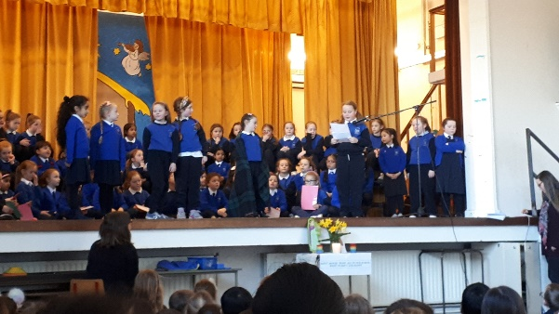

Second Class performing their St. Brigid’s Day Drama

**Spring is Here!**

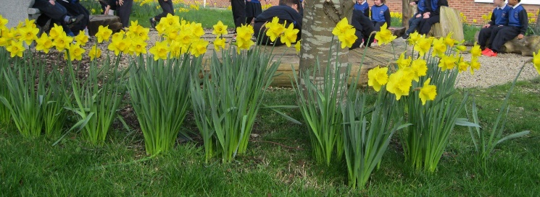

Spring is finally here! We are lucky to have a beautiful school garden full of flowers. You can see our lovely daffodils in bloom in the photo above. We are learning about how seeds grow. Some of the children in Senior Infants and Second Class are taking part in the *Incredible Edibles* programme. They will be learning where our food comes from by growing fruit and vegetables. Octavian, our gardener and Jimmy, our caretaker help us in the garden. Some of the children in Junior Infants have been planting seeds in their classrooms too. Let’s hope we will have some more lovely plants to enjoy by the summer! You can learn more about the *Incredible Edibles* by following this link: [https://www.incredibleedibles.ie/#](https://www.incredibleedibles.ie/)

**Green Schools**

This year we are hoping to get our 6th Green Flag for Global Citizenship Litter and Waste. Our Green Committee help us remember to reduce rubbish, reuse what we can and recycle. Let’s think green and hopefully we can get our new flag before the summer! You can find out more about Green Schools by following this link: <https://greenschoolsireland.org/>

**Access to School**

As you know we have been trying to control access to the school for reasons of child safety. Thank you for making a great effort to have your child in school, on time and entering by their correct door over the past week. The number of adults entering the school in the mornings has reduced and this has led to a calmer atmosphere for the children. Remember if you arrive late (up to 9am) your child should come in through their normal door. If you arrive later than 9am please bring your child through the main door to the school office. If you have information for the teacher, you can speak to them briefly on yard in the morning as the lines go in. Otherwise please send in a note if you would like the teacher to contact you after school. If it is an urgent message you can speak to our secretary Nora or our principal Jean in the morning and they can pass on any messages.

**Spring Art**

The walls of the school are filling up with beautiful samples of the children’s spring art. Inspired by our lovely garden no doubt, the boys and girls have produced lots of wonderful work.

