Special Guest Visit
Assumption Junior School hosted a very special guest this month when Leinster and Ireland rugby international Robbie Henshaw decided to pay us a visit! There was much excitement among pupils and staff on his arrival and the boys and girls asked Robbie some very interesting questions during our special assembly.
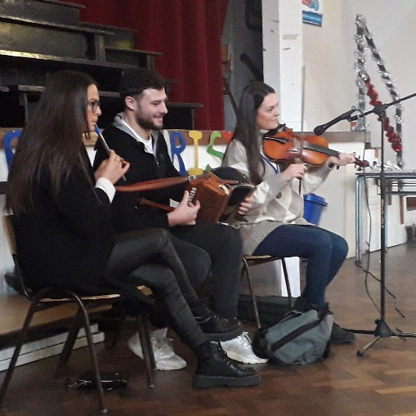
The Henshaws are a very talented musical family too, and we were delighted when Robbie and his sisters Emily and Ali (also known as Ms Henshaw around here!) treated us to a Christmas song singalong on their traditional instruments.
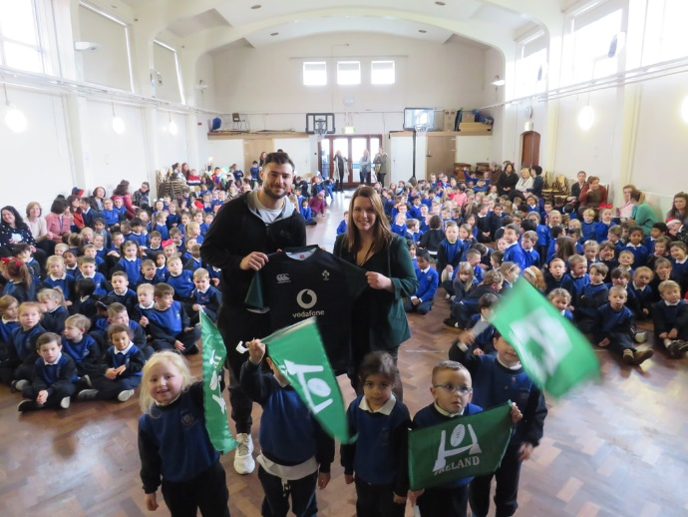
Robbie told the children that he played rugby, GAA and soccer as a child and it was great for them to hear such a strong message about the importance of physical activity. He presented the school with a signed jersey which we will be delighted to frame and display. Thank you to Ms Henshaw for organising this special visit.
Christmas Coffee Morning
Thank you for supporting our Annual Christmas Coffee Morning. It was run with great success again by our wonderful Parents’ Council on December 13th. Pupils and parents thoroughly enjoyed the day and weeks of hard work by the Parents’ Council members paid off as the hall looked beautiful and fantastic stands and raffle prizes were on offer. This is the Parents’ Council’s big fundraiser of the year and money raised on the day will directly benefit your child. Thank you also for supporting our Christmas card sale. These events require a lot of time and planning so a big thank you to Parents’ Council Chairperson Helen Delves and her team who always make it look so effortless!
Every School Day Counts
Thank you for taking part in Túsla’s Every School Day Counts initiative which ran during November. The classes from each year group with the highest attendance for the month who won a party were:
- Junior Infants – Ms Dever
- Senior Infants – Ms Looney
- First Class – Ms O’Connor
- Second Class – Ms Gilmer/ Ms Nestor
Congratulations also to Samira Assad, winner of the parent hamper for pupil full attendance which was very kindly sponsored by our local SuperValu Walkinstown.
Junior Infant Nativity
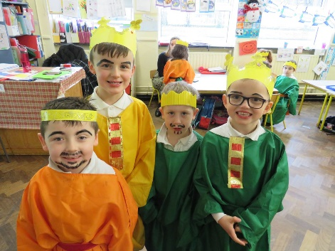
Our Junior Infant classes put on a beautiful performance of the Nativity in our school hall on December 10th. They had been practising hard all month and sounded amazing on the big days. Thanks to the hard work from the boys and girls and all their teachers and SNAs they all looked fantastic in their costumes. Thank you to all the parents, grandparents and friends who attended the show. Thanks to Second Class, their teachers and SNA who will treat us to a beautiful carols concert in the church tomorrow at 10.45am.
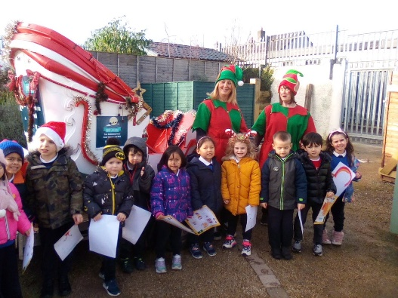
Santa Visit
Thank you to everyone in the Green Kitchen who organised a fantastic Santa visit for every child in the school!

