Christmas Coffee Morning
Thank you for supporting our Annual Christmas Coffee Morning. It was run with great success by our wonderful Parents’ Council on December 7th. Pupils and parents thoroughly enjoyed the day and weeks of hard work by the Parents’ Council members paid off as the hall looked beautiful and fantastic stands and raffle prizes were on offer. This is the Parents’ Council’s big fundraiser of the year and money raised on the day will directly benefit your child. Thank you also for supporting our Christmas card sale. There are certainly some budding Picassos in the school!
Lámh Signs
This half-term the school has been working on learning some Lámh sign language signs. This initiative was started by our wonderful SNAs who completed Lámh training during the year. Every class learns a new word each week and we’re all making a big effort to use this form of communication. We will learn lots more signs in the new year. To find out more about Lámh check out this site www.lamh.org
Christmas Carol Service
The girls from Second Class will be treating us to a Christmas Carol Service in the Parish Church on December 21st at 10.50am. They have been rehearsing their songs this month and it will be a beautiful way to kick off your Christmas holidays. All pupils and parents will be able to attend, and it should get us all in the Christmas spirit!
Teacher Shortage
There is currently a shortage of substitute teachers across the country and in Dublin in particular. All schools are affected by this. We are working hard to secure teachers to cover all leave but due in part to the cost of accommodation in Dublin many teachers are opting not to work in the city. We will prioritise having a teacher in every class in the new year, but it may lead to some days when your child’s class is split, or a support teacher may take the class. Please be assured that the Board of Management are acutely aware of this situation and we are doing everything we can to find suitable cover.
Child Protection
All the pupils are well settled into school now so should be entering the school with their line every day. Parents should not be accompanying children to their classrooms. If you arrive late (up to 9am) your child should come in through their normal door. If you arrive latter than 9am please bring your child through the main door where they will be able to go to their classrooms. If you have information for the teacher, you can speak to them briefly on yard in the morning as the lines go in. Otherwise please send in a note if you would like the teacher to contact you after school. If it is an urgent message you can speak to our secretary Nora or our principal Jean in the morning and they can pass on any messages. The Board of Management are concerned at the number of adults accessing the school during the day as this poses a child protection risk, and so the Board is currently looking into ways to limit traffic through the school. The safety of our pupils is paramount, and we would appreciate your help with this.
Junior Infant Nativity
Our Junior Infant classes put on two beautiful performances of the Nativity in our school hall on December 18th and 19th. They had been practising hard all month and sounded amazing on the big days. Thanks to the hard work from the boys and girls and all their teachers and SNAs they all looked fantastic in their costumes. Thank you to all the parents, grandparents and friends who attended the plays.
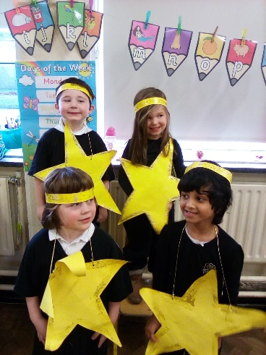
Ellie’s Xmas Heart – Thank You!
Thank you for supporting Ellie’s Xmas Heart, toy appeal for Crumlin Children’s Hospital this year. All toys have been donated to the hospital and will help to brighten the day for many sick children who sadly have to spend Christmas away from their homes.
Merry Christmas
The Board of Management and Staff of Assumption Junior School would like to wish all our pupils and their families a very happy and peaceful Christmas. The school will reopen on Monday, January 7th, 2019 at 8.50am.

