A Message from Our Chairperson
“The role of the Board of Management is to oversee the smooth running of the school. The Board prioritises the welfare and educational provision of all our pupils. It works hard to allocate the funds given to the school appropriately in order to create a safe, comfortable and well-resourced environment for all our pupils and staff. All Board members give their time and expertise voluntarily and receive no payment for carrying out their role. I hope that this end of year report will help to give all parents a flavour of the work that we have done this year. Thank you all for your support.”
Maura Sweeney (Chairperson, BOM)
Policy Work
Policies that the Board have worked on this year include:
- Assessment
- Code of Behaviour
- Mainstream Enrolment Policy
- ASDEI Enrolment Policy
- First Aid Procedures
- School Transport and Bus Escort Policy
- SEN Policy
- Leave Policy
- Stay Safe Policy
Health and Safety
This summer the Board is managing a Department of Education Summer Works grant. This grant will allow us to replace our external doors and install a fob system on our internal doors. We have listened to staff and parental concerns around the openness of our school building in recent years. Pupil safety is our top priority and we are delighted that this work is being carried out during the holidays as it will lead to a safer environment for all in Assumption Junior School.
Resources
This year the Board prioritised the redevelopment of our former multipurpose room into a gross motor skills and sensory room. A major problem with dampness was identified and rectified. New marmoleum flooring was fitted and the ceiling was insulated. The walls of a smaller adjoining room were also insulated and both rooms were repainted. A new heating system was installed. Adam & Friends were contracted to design and fit out the new room with multi-sensory equipment. The school staff and Board members are delighted with the results of this refurbishment and we know that our pupils will benefit hugely from having access to this state-of-the-art resource.

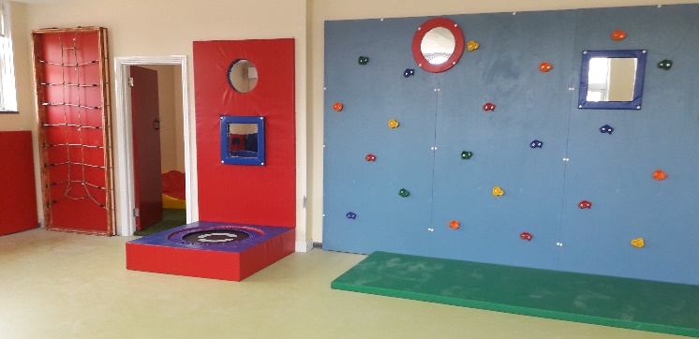
The Board will continue to work on improving the school’s resources next year. We plan to refurbish our original sensory room as well as making a significant investment in Aistear appropriate resources which will be hugely beneficial for all our Junior and Senior Infant pupils. We would like to thank all our pupils’ families for supporting our various fundraisers throughout the year, as without your support none of these improvements would be possible.
Thank You
The Board would like to thank several people without whom the smooth running of the school would not be possible. Thank you to our dedicated secretary Nora and our caretaker Jimmy who always ensure that we are all safe and well-organised! Thank you to Sue who organises our pupil lunches every day. Thank you to Octavian who has kept our garden looking beautiful all year. Thank you to the Religious Sisters of Charity, in particular Sr Lorraine, Sr Anne and Sr Kathleen whose presence in our school throughout the year is greatly appreciated. To Fr Paul who has played such an important role in preparing our pupils for their sacraments and supporting our staff all year. To our amazingly dedicated Parents’ Council who have worked tirelessly all year to organise the many wonderful events that make Assumption Junior School the vibrant place that it is. To our hard working After-School Carers who provide a happy environment for our pupils every day. And finally, to our teaching and SNA staff who work hard to put the needs of each and every pupil first in all that they do.

The school will reopen for the new year 2019/2020 on Thursday, August 29th at 8.50am.

We hope that you and your family enjoy a very happy summer break.

